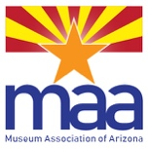 2021 Museum Association of Arizona Online Conference
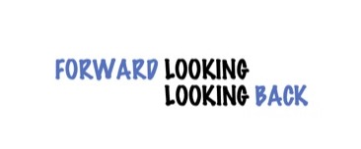

BY MAIL REGISTRATION FORM
Advance Registration must be received by September 30, 2021

If you are mailing your registration after September 24, 2021 please send an e-mail to azmuseums@gmail.com, letting us know to expect your form and check.

Please use a separate form for each registration.

1. Contact Information (Please use a separate form for each attendee)
Name
Title
Organization
E-mail
Mailing Address
Work Phone |  | Cell Phone
City | State |  | Zip

2. Conference Registration Fees (Please check your choice)
 | Full | $50
 | MAA Member | $30
 | Daily - October 4 | $20
 | Daily - October 5 | $20
 | Daily - October 7 | $20

Full Conference registration includes Zoom Meeting or phone access to:
Keynote Address
All Online Conference Presentations
Lunch Networking Conversations
Unlimited Access to Session Recordings

If you are not already an MAA member and wish to join to take advantage of the discount rate, you must do this before registering. You may enclose your membership form and check with your registration.
4. Payment
Registration | $
 | $
*Donation to Scholarship Fund | $
TOTAL | $

*The MAA Professional Development Scholarships provides financial assistance to Association members for attendance at an MAA-sponsored workshop or conference. For more information visit the MAA website: http://www.azmuseums.org/MAA-Scholarships

ALL ADVANCE REGISTRATIONS MUST BE RECEIVED BY September 30, 2021

If you are mailing your registration after September 24, 2021, please send an e-mail to azmuseums@gmail.com, letting us know to expect your form and check.

Please print this page and mail the completed form and check made out to “Museum Association of Arizona” to:
Museum Association of Arizona
PO Box 63902
Phoenix AZ 85082

For additional information and questions, please contact Janice Klein, MAA Executive Director at azmuseums@gmail.com

To register on-line using PayPal or a credit card visit the MAA website: http://www.azmuseums.org/page-1855943

