2019 Annual Archives Summit January 24 and 25, 2019

Tempe History Museum Public Meeting Room
809 E. Southern Ave, Tempe, AZ

Please RSVP to Dennis Preisler at dpreisler@azlibrary.gov or 602 926 3720

If you have any questions please contact Dennis Preisler at dpreisler@azlibrary.gov or 602 926 3720.

Sponsored by the Arizona Historical Records Advisory Board (AHRAB) Funded by the NHPRC and AZAA

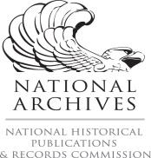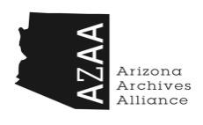

Agenda

Thursday, January 24, 2019, 8:30 a.m. to 5:00 p.m.

Protocols for Native American Archival Materials
Information versus Knowledge
Counter Narratives in the Archives
Developing Relationships

Friday, January 25, 2019, 8:30 a.m.-4:45 p.m.

The Professional Archives Development Program
Archives and Internships
Archives Month
Arizona Archives Alliance
AHRAB Regrant Program
Grants and Grant Opportunities

